**A CRM application for local business management**

1. **Project Overview :**

This project is focused on creating a Local Business CRM, designed to address the challenge of efficiently managing customer relationships, inventory, appointments, and services for local businesses. The goal is to deliver a comprehensive solution by leveraging Salesforce's CRM capabilities and automation tools. Through this project, we aim to enhance operational efficiency, improve customer satisfaction, and increase data accuracy to support the long-term goals of small and medium-sized businesses in optimising customer engagement and streamlining business operations.

1. **Objectives :**

**Business Goals:**

1. Improve customer relationship management by providing a centralised platform for tracking interactions, preferences, and purchase history.
2. Enhance operational efficiency by automating key business processes, such as appointment scheduling, order tracking, and inventory management.
3. Increase customer satisfaction through better service tracking and timely response to inquiries.
4. Enable data-driven decision-making by generating insights from customer data and sales trends.
5. Enhance operational efficiency by automating key business processes, such as appointment scheduling, order tracking, and inventory management.
6. Increase customer satisfaction through better service tracking and timely response to inquiries.
7. Enable data-driven decision-making by generating insights from customer data and sales trends.

**Specific Outcomes:**

1. Streamlined Onboarding: Simplified process to quickly onboard new customers, capturing essential details and preferences.
2. Centralised Customer Data: A unified repository for storing customer information, orders, feedback, and service history.
3. Automated Scheduling and Reminders: Automated appointment scheduling for services with customer reminders to reduce no-shows.
4. Inventory Management System: Real-time tracking of products and stock levels to avoid overstocking or stockouts.
5. Enhanced Reporting and Analytics: Detailed reports on sales trends, customer preferences, and service demand to support business strategy.
6. **Salesforce Key Features and Concepts Utilized : Custom Objects:** Created custom objects for Customer, Product/Service, Order, Appointment, Feedback etc to capture and organize essential business data relevant to local business management.

### **Record Types and Page Layouts:**Utilized different record types and customized page layouts for Product and Service offerings, ensuring relevant fields are displayed based on the type of record being viewed.

### 

### **Apex Trigger Automation:**Developed an Apex trigger to automate the process of setting default values for key fields on custom objects like Appointments. For example, the trigger automatically sets the Status field on new Appointment records to "Scheduled" upon creation, ensuring data consistency and reducing manual entry.

### 

### **Automation with Flow:** Developed automation flows for:

* New Customer Onboarding: Guides staff through a standardized customer registration process.
* Local Business Approval Process: Automates internal approval for orders or appointments that need verification.

### 

**Decision Elements:** Configured decision elements within flows to determine if a customer is interested in a product or service and prompt relevant follow-up actions.

**Validation Rules:** Enforced business rules to ensure data accuracy, such as checking that required fields like Customer Contact Info and Order Details are completed before record saving.

### **Picklists and Dependent Picklists:**Created picklist fields for Service Category and Product Type to standardize data entry, with dependent picklists for specifying subcategories where applicable.

### **Reports and Dashboards:**Built reports to track Customer Orders, Appointments, and Inventory Levels and a dashboard for visual summaries of key metrics like Monthly Sales, Customer Satisfaction Ratings, and Inventory Status.

### **Email Alerts and Notifications:**Configured email alerts to notify staff when a new order is placed or an appointment is scheduled, ensuring timely follow-up with customers.

### 

### **Roles and Permissions:**Defined roles and set permission levels for various user profiles, such as Sales Representatives, Managers to control data access based on user responsibilities.

### 

### **Salesforce Mobile App:**Enabled mobile access to provide field staff with easy access to customer and appointment information, allowing for on-the-go updates and check-ins.

**4. Detailed Steps to Solution Design :**

**1. Data Model Design:**The data model forms the backbone of the CRM system. Here's an outline for the entities (custom objects), relationships, and fields involved in the Local Business CRM project.

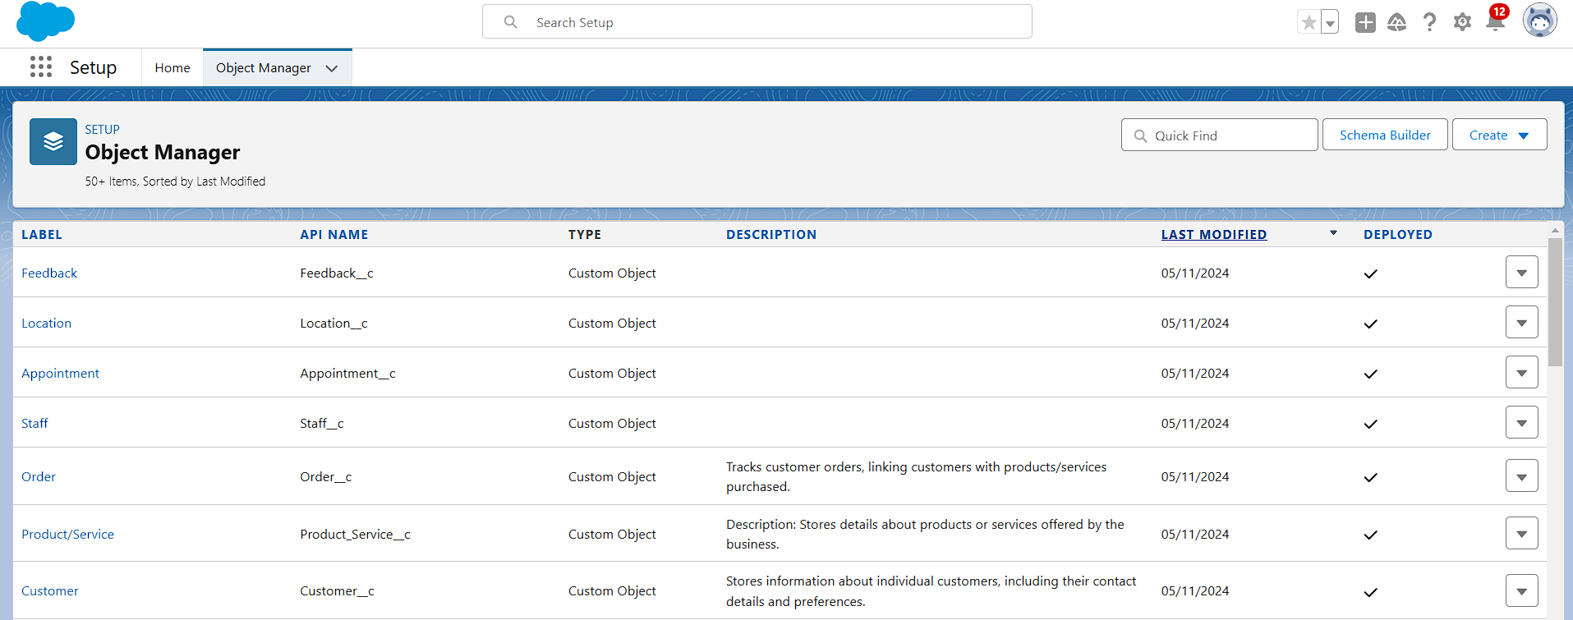

##### **Custom Objects & Fields:**

1. **Customer__c(Custom Object):** Stores information about individual customers, including their contact details and preferences.

**Fields:**

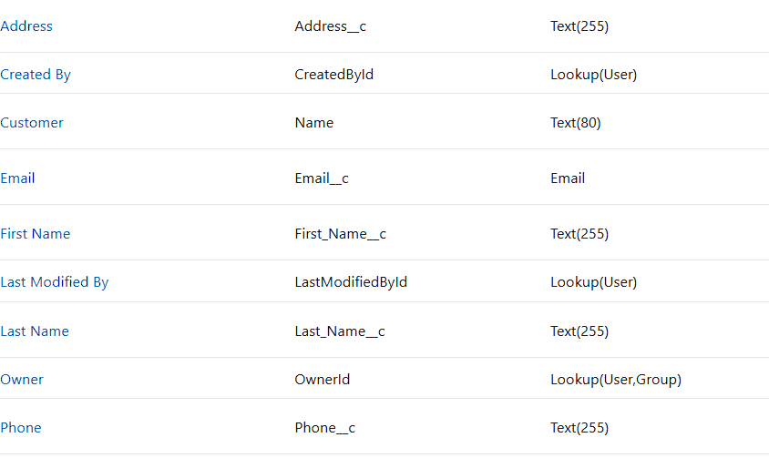

1. **Product/Service__c (Custom Object):** Stores details about products or services offered by the business.
   * **Fields:**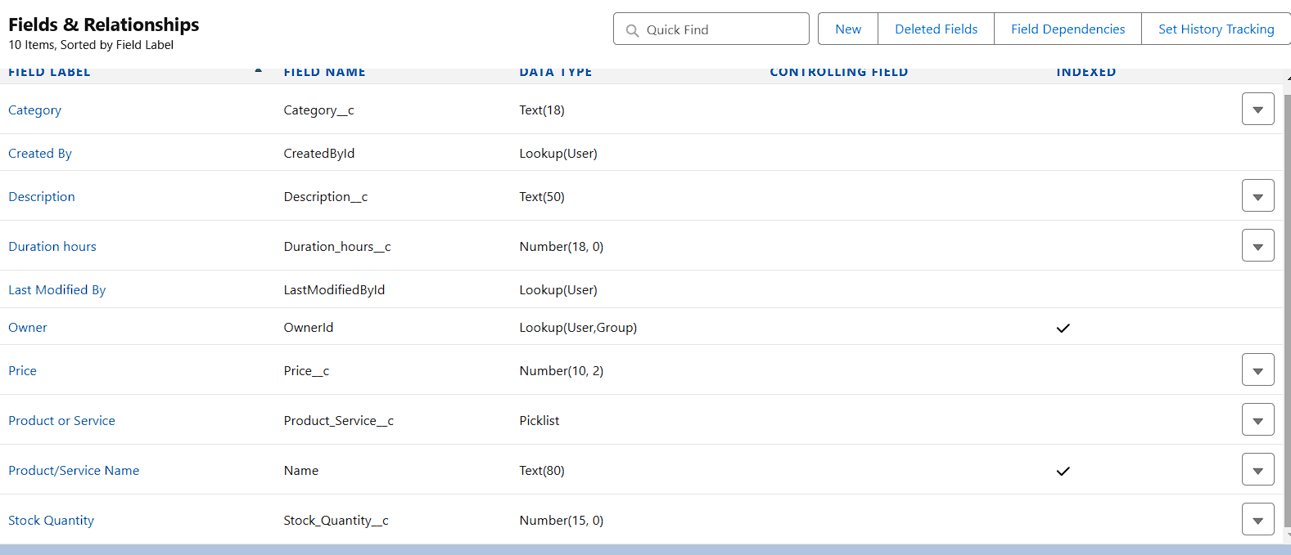
2. **Order__c (Custom Object):** Stores details about products or services offered by the business.
   * **Fields:**

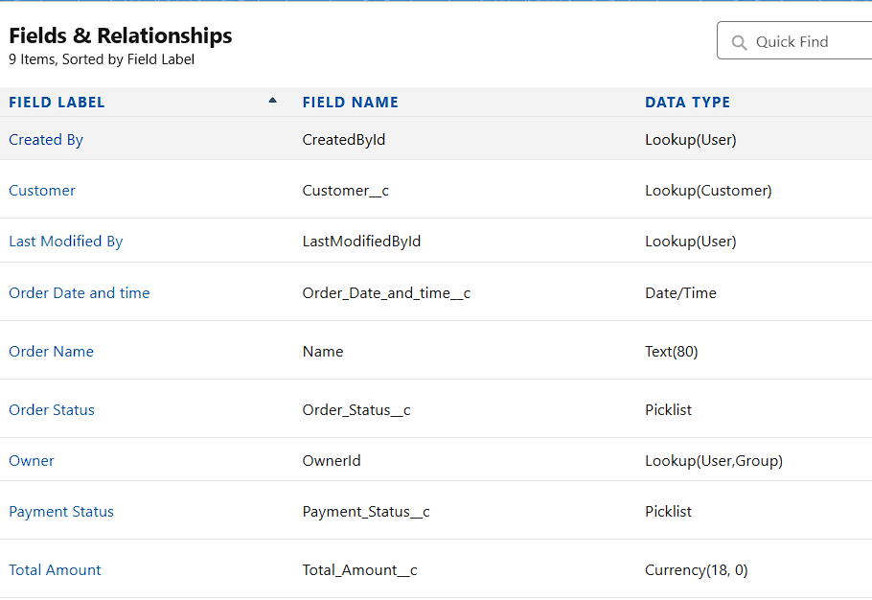

1. **Appointment__c (Custom Object):** Manages appointments for services that require scheduled interactions with customers.
   * **Fields:**

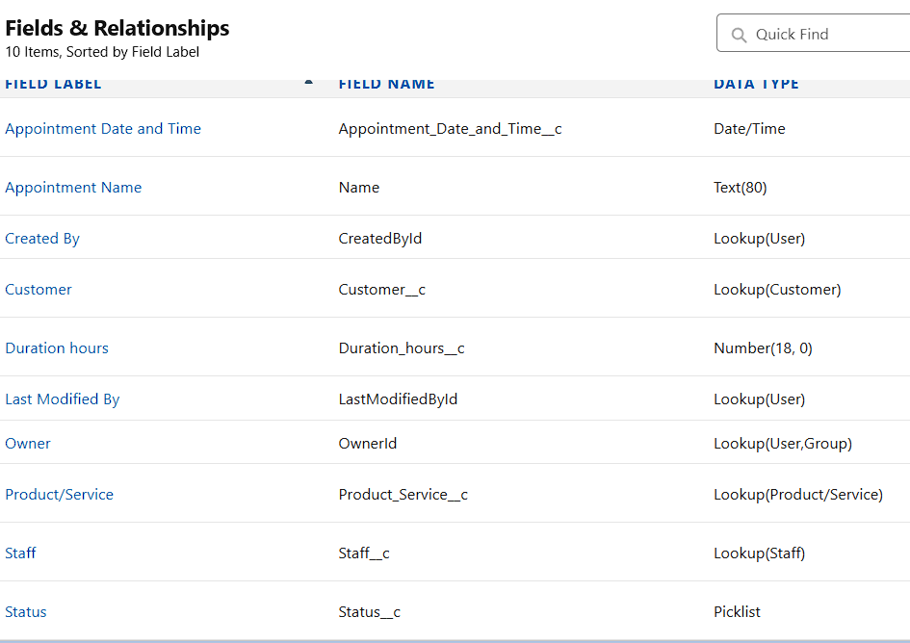

1. **Feedback__c (Custom Object) :** Collects customer feedback on products/services and overall satisfaction.**Fields:**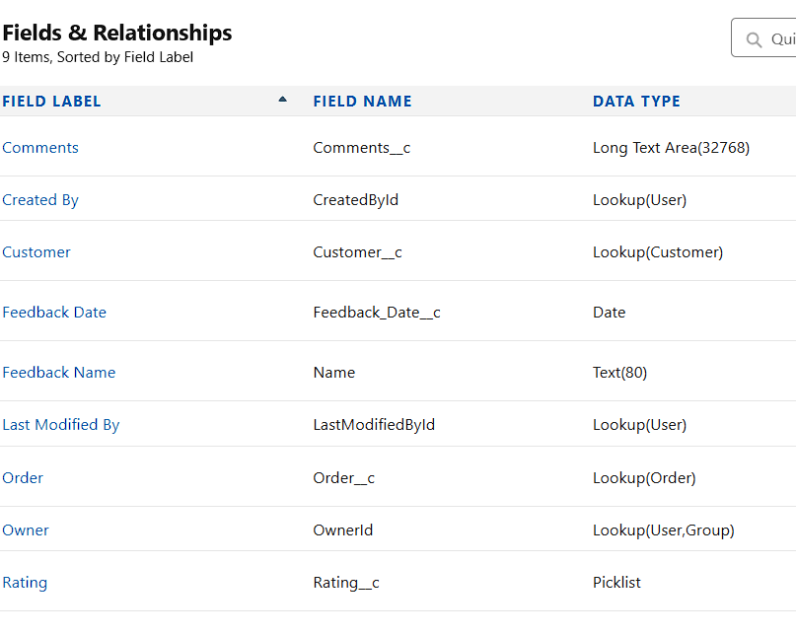
2. **Location :** Useful for businesses with multiple branches or service locations.

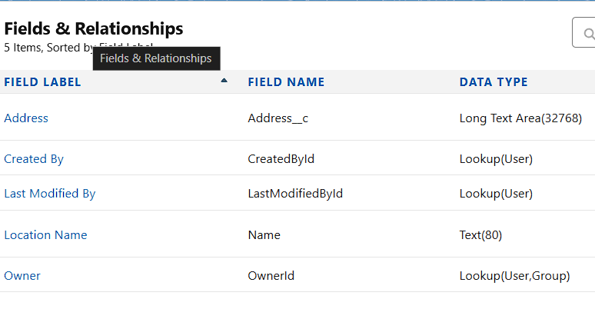

2. **Automation with Flow:** Developed automation flows for:

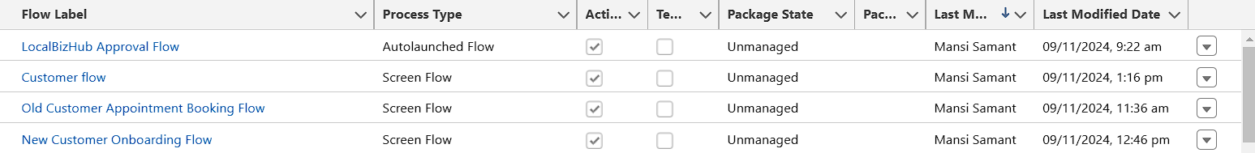

* **New Customer Onboarding Flow:** Automates the process of registering and capturing essential details for new customers.

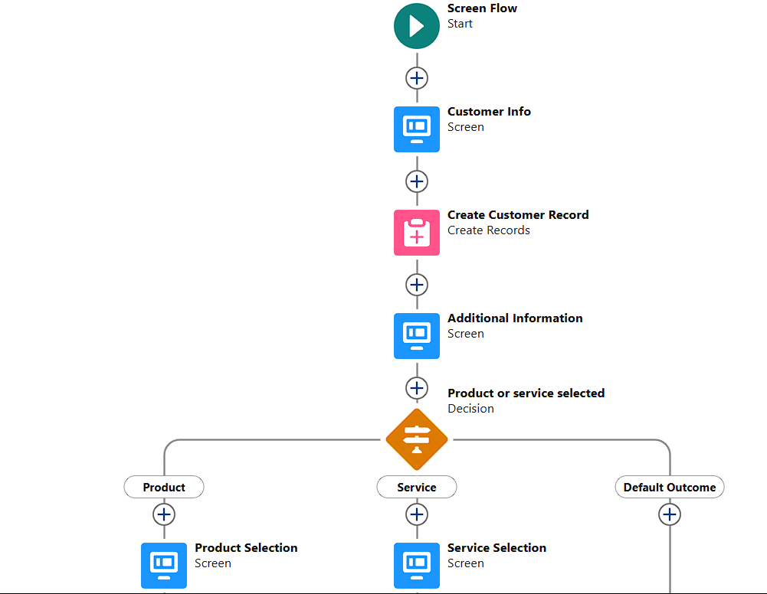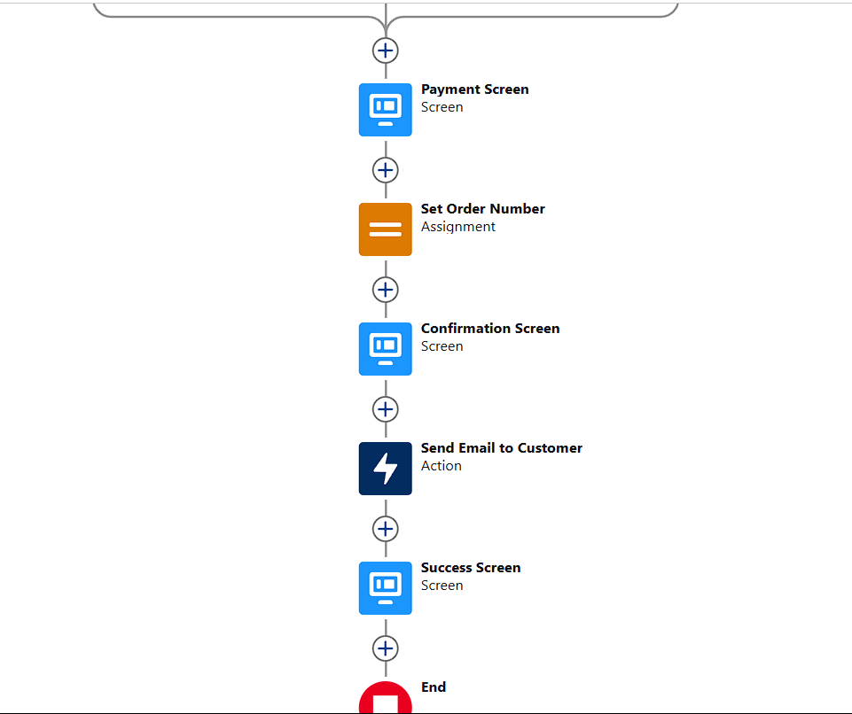

* **Old Customer Appointment Booking Flow**: Streamlines the scheduling of appointments for existing customers.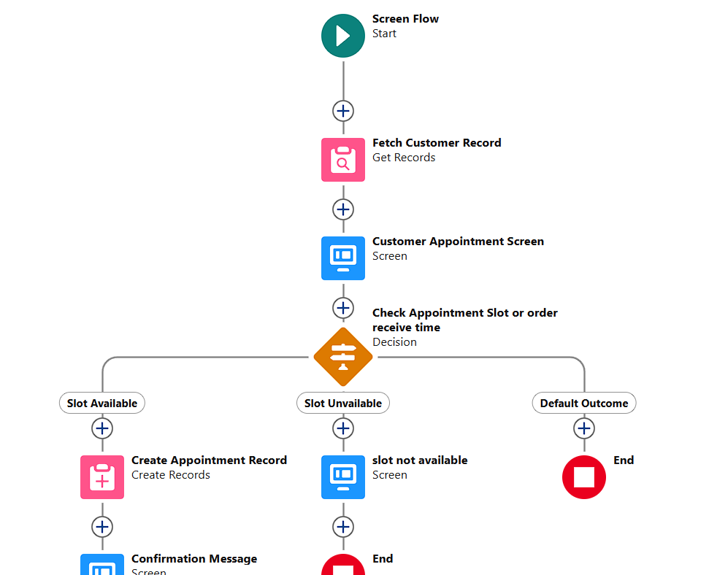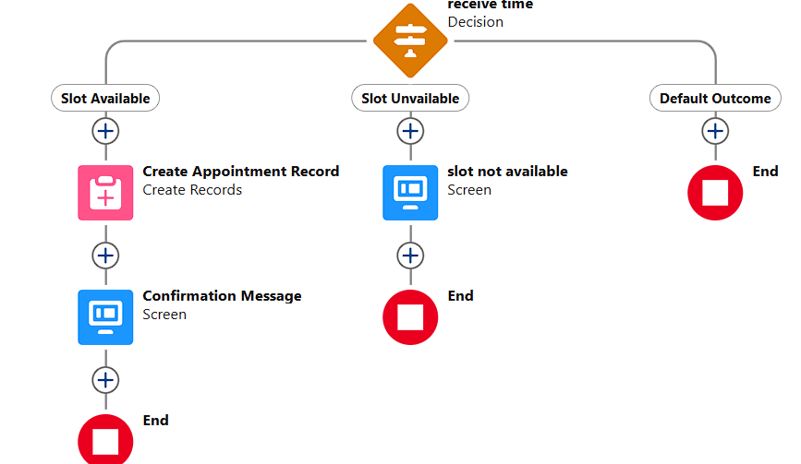
* **Customer Flow (Connects All Flows)**: Integrates multiple customer-related flows for a seamless user experience.

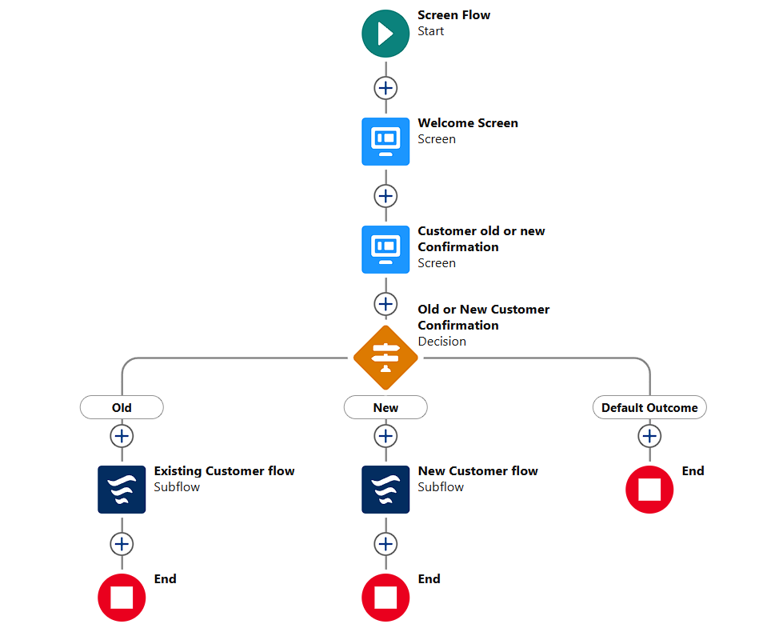

* **LocalBiz Approval Flow (Autolaunched)**: Automatically handles approval requests for local business registrations.:

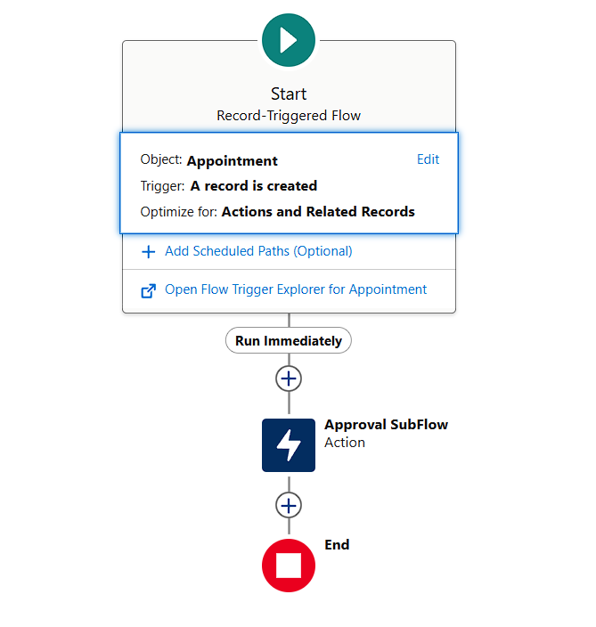

#### **3. Apex Trigger for Appointment Status:**

* **Description:** The Apex trigger sets the default status to "Pending" on new Appointment records.
* **Implementation**: Used after insert logic to check if Status is null, then assign "Scheduled".

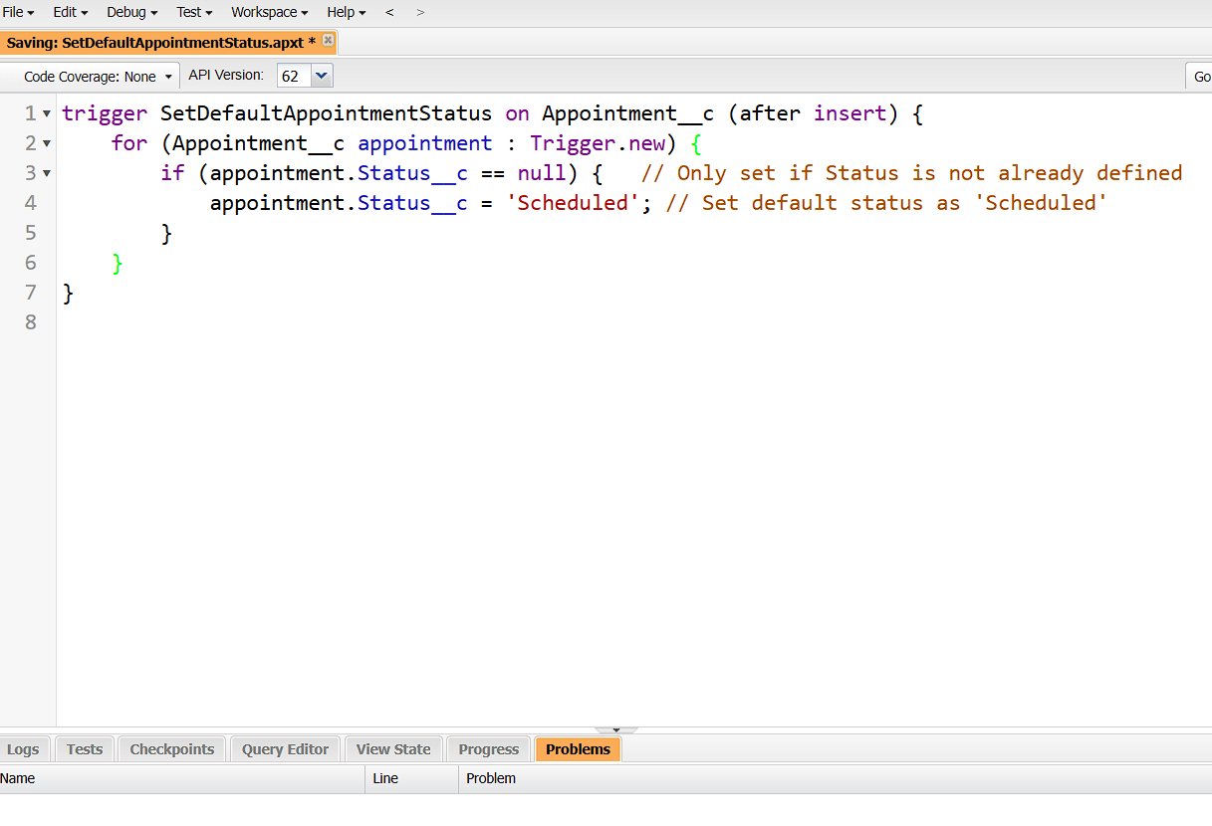

**4. Validation Rules**

* **Business Rules**: Enforce that required fields like Credit card number , cvv etc are populated.

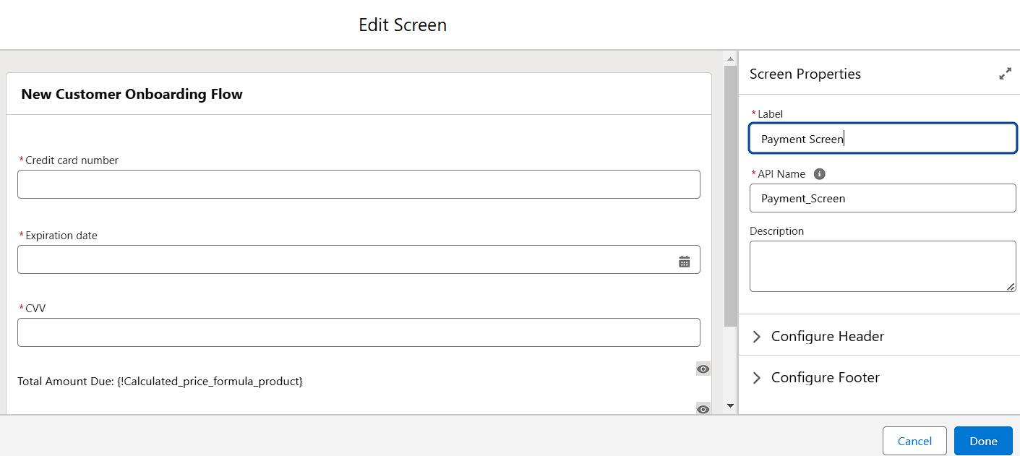

#### 

#### **5. Additional Functionality**

1. **Picklists and Dependent Picklists**
   * **Setup**: Created fields like Service Category and Product Type with dependent options.

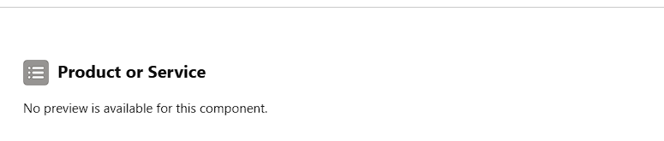

1. **Email Alerts and Notifications**
   * **Purpose**: Order Confirmation email.

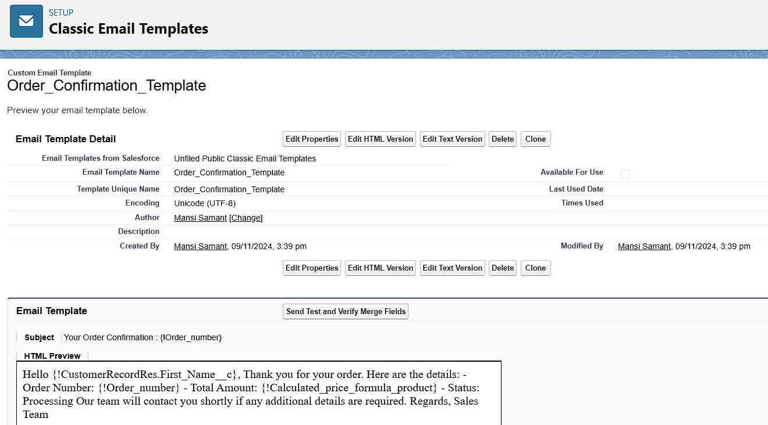

### **5. Testing and Validation**

To ensure the reliability and functionality of the local business CRM system, a structured approach to testing will be employed. This includes unit testing of Apex classes and triggers, as well as user interface testing. Each type of testing will be designed to verify specific aspects of the system and ensure that all components meet requirements.

**6. Key Scenarios Addressed by Salesforce in the Implementation Project**

Salesforce's capabilities in this implementation provide a range of solutions to common scenarios encountered by local businesses. Below are the primary scenarios addressed by this CRM solution, along with a description of how Salesforce manages each situation effectively.

#### **1. Customer Data Management**

**Scenario:** The business requires a streamlined system to capture, organize, and access detailed customer information.

Salesforce Solution:

* Custom Objects: Created custom objects for storing essential details, such as customer contact information, address, and service preferences.
* Centralized Customer Profiles: Allows staff to view and update customer information, ensuring up-to-date and easily accessible records for personalized service.

#### **2. Automated Appointment Scheduling**

Scenario: Manual appointment scheduling and updates lead to inefficiencies and missed follow-ups.

Salesforce Solution:

* Custom Object and Trigger for Appointments: Automated status assignment using an Apex trigger that defaults the status to “Pending” upon creation, ensuring consistency and reducing manual effort.
* Automation Flow for Appointment Confirmation: Configured a flow to send email notifications for appointments, keeping both customers and staff informed and improving reliability in follow-ups.

#### **3. Product and Service Categorization**

Scenario: The business offers a variety of products and services and requires an organized approach to categorizing offerings.

Salesforce Solution:

* Record Types and Page Layouts: Created distinct record types and page layouts for products and services, ensuring relevant fields are displayed based on the type of offering.
* Picklists and Dependent Picklists: Implemented picklists for categories and subcategories, standardizing data entry and making it easy to filter and locate specific products or services.

#### **4. New Customer Onboarding Process**

Scenario: Inconsistent onboarding processes lead to gaps in customer data and variable customer experiences.

Salesforce Solution:

* Flow for Standardized Onboarding: Developed an onboarding flow to guide staff through each step, ensuring a consistent and efficient process.
* Validation Rules: Enforced completion of mandatory fields (e.g., contact info) to ensure all essential customer details are recorded accurately.

#### **5. Local Business Approval Workflow**

Scenario: Certain orders or appointments require internal verification or approval before they can proceed.

Salesforce Solution:

* Approval Process Automation: Built flows for managing approval steps, automating notifications to relevant staff for quick review and decision-making.
* Decision Elements: Configured decision elements in the flow to prompt different actions based on customer preferences, enhancing the approval workflow’s adaptability.

#### **6. Role-Based Data Access**

Scenario: Different team members require varied levels of access to customer and order data based on their roles.

Salesforce Solution:

* Roles and Permissions: Defined custom roles (e.g., Sales Representative, Manager, Support Staff) and set permissions to control data visibility and editing capabilities, ensuring sensitive information is accessible only to authorized users.

**7. Conclusion :**

#### **Summary of Achievements**

The implementation of Salesforce CRM for local business management has successfully established a cohesive and efficient system tailored to the unique needs of the business. Key accomplishments of this project include:

* Custom Data Structure: Created custom objects for Customer, Product/Service, Order, Appointment, and Feedback, providing a well-organized database for critical business information.
* Enhanced User Interface: Developed record types and customized page layouts, delivering a user-friendly interface that shows relevant fields based on the type of record, reducing confusion and improving usability.
* Automated Workflows and Processes: Leveraged Apex triggers, flows, and approval processes to automate repetitive tasks, such as setting default statuses, onboarding customers, and managing appointment approvals. This automation saves time and ensures consistency.
* Data Accuracy and Standardization: Implemented validation rules and dependent picklists, enforcing data entry standards and maintaining high data quality, which aids in generating accurate reports and insights.
* Real-Time Data Access and Analysis: Built comprehensive reports and dashboards to track orders, appointments, and inventory levels, empowering management with insights into key metrics, such as sales and customer satisfaction.
* Responsive Customer Engagement: Configured email alerts and notifications for customer interactions, ensuring timely follow-up and enhancing the customer experience through effective communication.
* Secure Access Control: Defined roles and permissions for various user profiles, ensuring data security by controlling access based on employee responsibilities.

Through these achievements, Salesforce has transformed local business operations, enabling streamlined processes, reliable data management, and improved customer service. This implementation establishes a scalable foundation that can adapt to future business growth and evolving needs.